**Error occurs:**

**1) Why did this error occur?**

Ansible couldn't find a package called python3 in the system's package repositories for server2.

Possible Reasons:

Server2 have lower versions like python2

The system uses a different package manager (e.g., apt vs yum vs dnf )

**2) How can you modify you playbook to handle this issue dynamically using ansible facts?**

Each system uses difference os like ubuntu uses apt, Redhat uses yum.

Using when clause in playbook we can declare and install easily.

**3) Write a playbook snippet that ensures python3 gets installed correctly on any Linux distribution?**

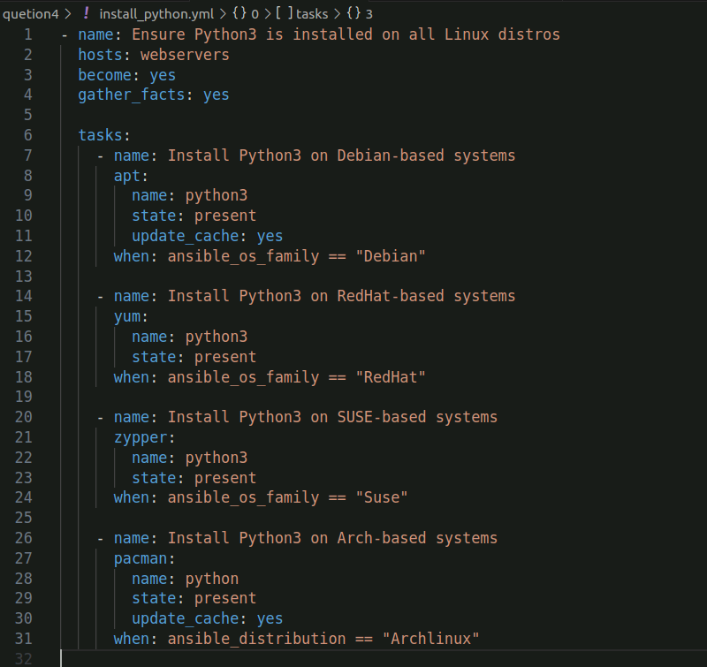

**Run playbook**

